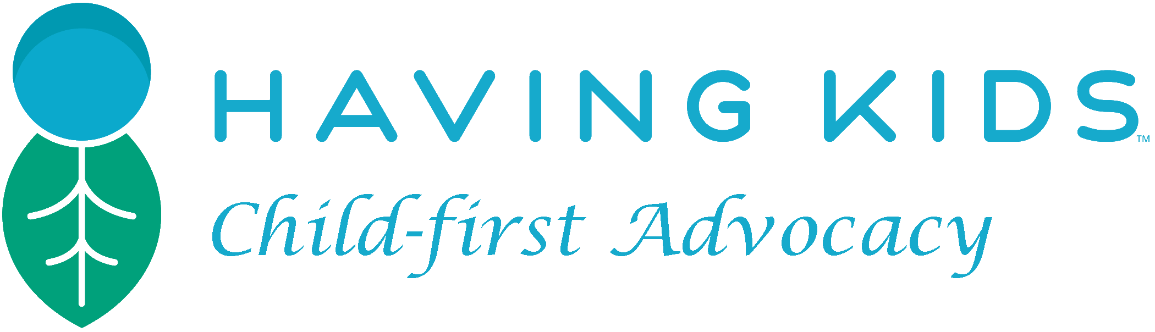

Month XX, 2017

Honorable Mayor X and Members of the City Council:

Having Kids, a nonprofit organization that advocates for smaller and sustainable families, is urging local governments around the United States to take effective action to respond to climate change. We hope you will consider incorporating in your official response to climate change what could be the most effective but underutilized tool: family planning.

Studies have repeatedly shown that family planning is the most effective means of mitigating climate change and its impacts. For example, a study by statisticians at Oregon State University found that the greenhouse gas impact of having an additional child in the U.S. is almost twenty times greater than the savings from a lifetime of recycling, reducing, and reusing. They also found that each child born in the U.S. will add about 9,441 metric tons of carbon dioxide to the carbon legacy of an average parent. The study concludes, “[c]learly, the potential savings from reduced reproduction are huge compared to the savings that can be achieved by changes in lifestyle.”

Yet the United States has the highest fertility rate of any industrialized country, and because of its high level of consumption is a much greater contributor to climate change than developing countries with higher fertility rates. Moreover, over half of United States pregnancies are unplanned, which shows a pressing need for family planning policy reform and increased services.

As such, we are urging you to consider

- Explicitly recognizing in your climate action plan – or elsewhere – the role family planning plays in climate change;

- Implementing, in your family planning programming or elsewhere, any family planning model that promotes smaller, more sustainable, and more equitable families that provide every child a fair start.

If you are interested and require more information, please see our draft white paper (bit.ly/HKWhitePaper), and/or contact Having Kids at Info@HavingKids.org

Thank you for your time and consideration.

Sincerely,

signature

Having Kids Advocate

Address, etc.

Seth Wynes and Kimberly A Nicholas, The climate mitigation gap: education and government recommendations miss the most effective individual actions. 12 Environ. Res. Lett 7. (2017); Guillebaud, John, and Pip Hayes. Population growth and climate change. BMJ 2008; 337; a576; Rosnick, David, The Consequences of Increased Population Growth for Climate Change. Center for Economic and Policy Research (2014). http://cepr.net/documents/Climate-population- 2014-12.pdf; Population Matters Report: Population key to controlling climate change (2017). https://www.populationmatters.org/report-population-key-controlling-climate-change
Paul A. Murtaugh & Michael G. Schlax, Reproduction and the Carbon Legacies of Individuals, 19 Global Envtl. Change 14, 18 (2009).
L.B. Finer and M.R. Zolna, Unintended pregnancy in the United States: incidence and disparities, 2006, 84 Contraception 478 (Nov. 2011).

